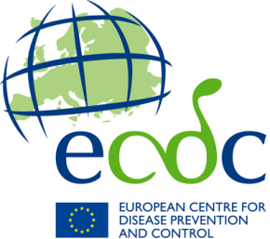

fInal report
Food- and Waterborne Diseases and Zoonoses
Expert Exchange Programme for public health experts in food and waterborne diseases, Legionnaires’ disease and variant Creutzfeldt-Jakob disease (FWDEEP)

First name
Surname
Email address
Current place of employment
Role/ Job title
Dates of exchange
Hosting institution
Address
Contact at host site/institute
Contact’s role at host institute
Exchange type (Trainee or Trainer)

*In the case of a trainer exchange, this report should be filled in jointly between the applicant and the host institution. In the case of a trainee exchange, the trainee is solely responsible for the report.
Summary of activities and experience (In English, max. 300 words)

Achieved learning and troubleshooting (if relevant) (In English, max. 100 words)

Skills acquired or transferred during exchange (In English, max. 200 words)

Plans to cascade the acquired knowledge to your institute and at a national level in order to expand capacity and competence (In English, max. 300 words)

Please provide feedback on what went well during the exchange (In English, both in terms of content and organisational aspects)

Please provide feedback on what could be improved (In English, both in terms of content and organisational aspects)

Any other comments on the exchange (any language)

